**Course 3 Concurrency**

# Week 1

## M1.1.1-3v3 Parallel Execution

* Two Programs execute in parallel if they execute at exactly the same time
* Generally, one core runs one instruction at a time
* In order to get parallel execution, you need replicated hardware

## Topic 1.2 Von Neumann Bottleneck

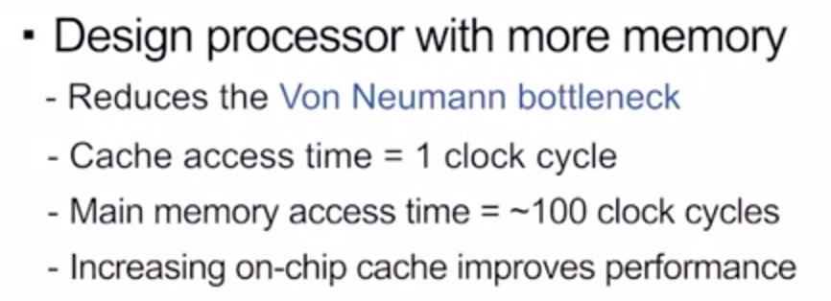

* Moore’s Law is fizzling out

## Topic 1.3 Power Wall

* Transistors consume power when they switch
* More power consumed – increased heat 🡪 ECE 304
* 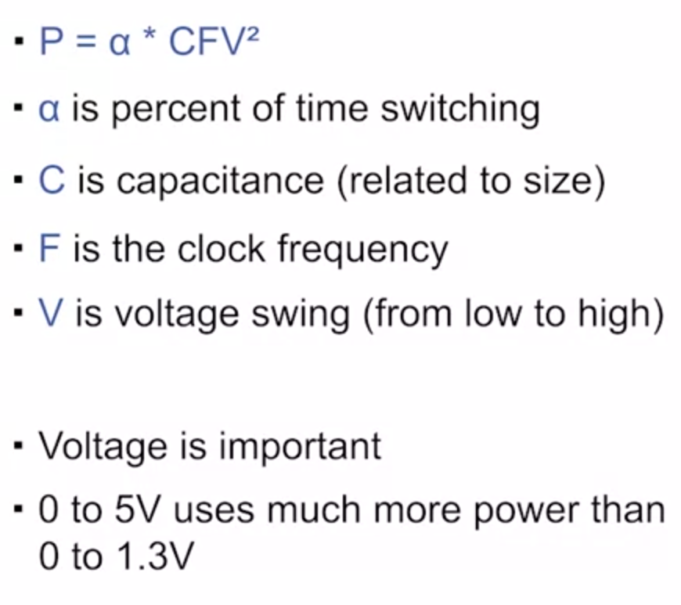

Dennard Scaling:

* Voltage should scale with transistor size
* Voltage can’t go too low though
  + Can’t drop below threshold voltage
  + Must be robust to noise